EXERCISE – 09 (DECISION TREE)
1. AIM
To build a Decision Tree classifier for heart disease prediction and to evaluate and visualize the trained model.
2. ALGORITHM
1. Load the dataset and separate the features from the target Heart Disease.
2. Identify the numerical and categorical columns.
3. Build the preprocessing pipeline that scales the numerical features and one-hot encodes the categorical features.
4. Split the data into training and testing sets in an 80:20 ratio with stratification.
5. Train a DecisionTreeClassifier with max_depth = 4.
6. Predict the test set and calculate accuracy, precision, recall, F1 score, the classification report and the confusion matrix.
7. Visualize the confusion matrix and the trained decision tree.
3. PROGRAM
import pandas as pd
import matplotlib.pyplot as plt
from sklearn.model_selection import train_test_split
from sklearn.compose import ColumnTransformer
from sklearn.preprocessing import OneHotEncoder
from sklearn.pipeline import Pipeline
from sklearn.tree import DecisionTreeClassifier
from sklearn.tree import plot_tree
from sklearn.metrics import (
accuracy_score,
precision_score,
recall_score,
f1_score,
confusion_matrix,
classification_report,
ConfusionMatrixDisplay
)
df = pd.read_csv("heart_disease_dataset.csv")
print("First 5 rows:")
print(df.head())
print("\nDataset Shape:")
print(df.shape)
X = df.drop("Heart Disease", axis=1)
y = df["Heart Disease"]
print("\nFeatures:")
print(X.columns)
print("\nTarget:")
print(y.name)
categorical_columns = X.select_dtypes(
include=["object"]
).columns
numerical_columns = X.select_dtypes(
exclude=["object"]
).columns
print("\nCategorical Columns:")
print(list(categorical_columns))
print("\nNumerical Columns:")
print(list(numerical_columns))
preprocessor = ColumnTransformer(
transformers=[
(
"cat",
OneHotEncoder(handle_unknown="ignore"),
categorical_columns
)
],
remainder="passthrough"
)
decision_tree = DecisionTreeClassifier(
criterion="gini",
max_depth=4,
random_state=42
)
model = Pipeline(
steps=[
("preprocessor", preprocessor),
("classifier", decision_tree)
]
)
model = Pipeline(
steps=[
("preprocessor", preprocessor),
("classifier", decision_tree)
]
)
X_train, X_test, y_train, y_test = train_test_split(
X,
y,
test_size=0.20,
random_state=42,
stratify=y
)
print("\nTraining Data:", X_train.shape)
print("Testing Data:", X_test.shape)
model.fit(X_train, y_train)
print("\nDecision Tree Model Trained Successfully!")
y_pred = model.predict(X_test)
accuracy = accuracy_score(y_test, y_pred)
precision = precision_score(
y_test,
y_pred,
zero_division=0
)
recall = recall_score(
y_test,
y_pred,
zero_division=0
)
f1 = f1_score(
y_test,
y_pred,
zero_division=0
)
print("\n==========================================")
print(" DECISION TREE EVALUATION")
print("==========================================")
print("Accuracy :", round(accuracy, 4))
print("Precision :", round(precision, 4))
print("Recall :", round(recall, 4))
print("F1 Score :", round(f1, 4))
# ==========================================
# 12. Classification Report
# ==========================================
print("\nClassification Report:")
print(classification_report(y_test, y_pred))
# ==========================================
# 13. Confusion Matrix
# ==========================================
cm = confusion_matrix(y_test, y_pred)
print("\nConfusion Matrix:")
print(cm)
disp = ConfusionMatrixDisplay(
confusion_matrix=cm,
display_labels=["No Heart Disease", "Heart Disease"]
)
disp.plot()
plt.title("Confusion Matrix - Decision Tree")
plt.show()
# Get the trained classifier
tree_model = model.named_steps["classifier"]
# Get feature names after One-Hot Encoding
feature_names = model.named_steps[
"preprocessor"
].get_feature_names_out()
plt.figure(figsize=(25, 12))
plot_tree(
tree_model,
feature_names=feature_names,
class_names=["No Heart Disease", "Heart Disease"],
filled=True,
rounded=True,
fontsize=8
)
plt.title("Decision Tree for Heart Disease Classification")
plt.show()

4. OUTPUT
The program was executed on the Heart disease dataset (heart_disease_dataset.csv) and produced the following output:
First 5 rows:
Age Gender ... Chest Pain Type Heart Disease
0 75 Female ... Atypical Angina 1
1 48 Male ... Typical Angina 0
2 53 Male ... Atypical Angina 1
3 69 Female ... Non-anginal Pain 0
4 62 Female ... Asymptomatic 0
[5 rows x 16 columns]
Dataset Shape:
(1000, 16)
Features:
Index(['Age', 'Gender', 'Cholesterol', 'Blood Pressure', 'Heart Rate',
'Smoking', 'Alcohol Intake', 'Exercise Hours', 'Family History',
'Diabetes', 'Obesity', 'Stress Level', 'Blood Sugar',
'Exercise Induced Angina', 'Chest Pain Type'],
dtype='object')
Target:
Heart Disease
Categorical Columns:
['Gender', 'Smoking', 'Alcohol Intake', 'Family History', 'Diabetes', 'Obesity', 'Exercise Induced Angina', 'Chest Pain Type']
Numerical Columns:
['Age', 'Cholesterol', 'Blood Pressure', 'Heart Rate', 'Exercise Hours', 'Stress Level', 'Blood Sugar']
Training Data: (800, 15)
Testing Data: (200, 15)
Decision Tree Model Trained Successfully!
==========================================
DECISION TREE EVALUATION
==========================================
Accuracy : 1.0
Precision : 1.0
Recall : 1.0
F1 Score : 1.0
Classification Report:
precision recall f1-score support
0 1.00 1.00 1.00 122
1 1.00 1.00 1.00 78
accuracy 1.00 200
macro avg 1.00 1.00 1.00 200
weighted avg 1.00 1.00 1.00 200
Confusion Matrix:
[[122 0]
[ 0 78]]
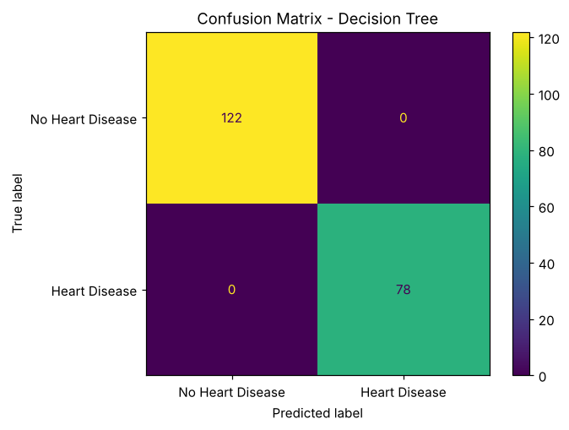
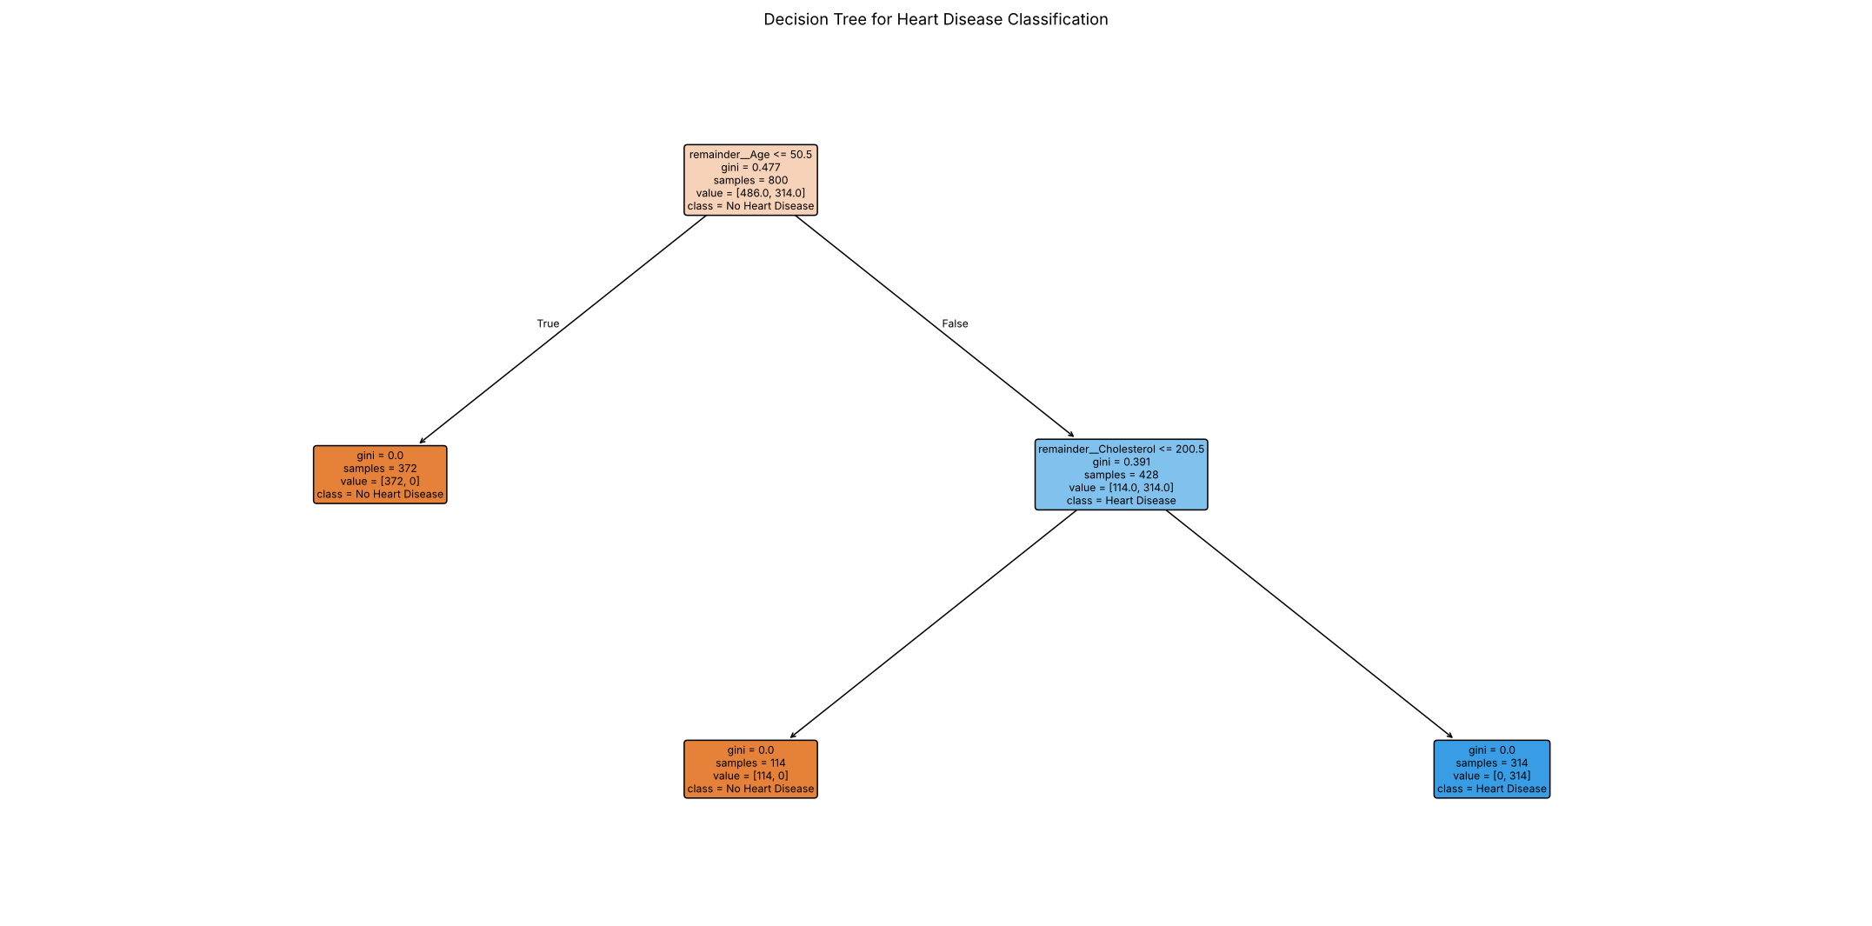

5. RESULT
Thus, the Decision Tree practical was implemented successfully. The tree of depth 4 classified all 200 test records correctly (accuracy, precision, recall and F1 score of 1.0), as shown by the confusion matrix with 122 true negatives and 78 true positives.

